AGENDA FOR THE
MEDINA MUNICIPAL/REGIONAL
PLANNING COMMISSION MEETING
MONDAY, JULY 6, 2026
5:30 PM

I. DETERMINATION OF QUORUM AND CALL TO ORDER

II. REVIEW AND APPROVAL OF MINUTES

III. CITIZENS COMMENTS

IV. NEW BUSINESS

- Final Plat – Heath Minor Subdivision

- Final Plat – Tammy Murphree Minor Subdivision

V. OLD BUSINESS

VI. OTHER BUSINESS

VII. ADJOURNMENT


MEMORANDUM

TO: Medina Municipal / Regional Planning Commission
FROM: Donny Bunton, Community Planner
DATE: June 30, 2026
SUBJECT: STAFF PLANNER’S REPORT ON AGENDA ITEMS

I. DETERMINATION OF QUORUM AND CALL TO ORDER
II. REVIEW AND APPROVAL OF MINUTES
III. CITIZENS COMMENTS
IV. NEW BUSINESS

- Final Plat – Heath Minor Subdivision

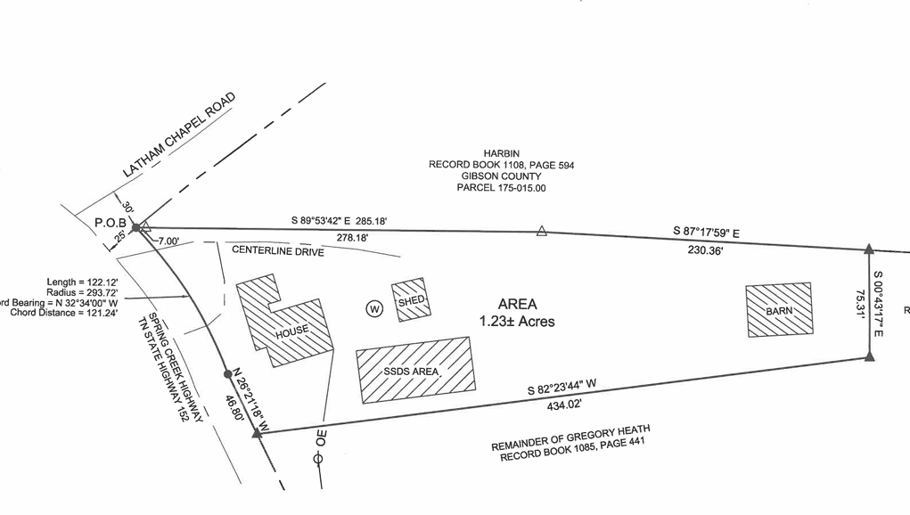

Background. A minor subdivision plat has been submitted which proposes to subdivide one lot from a parent tract (of approximately 43.16 acres). The proposed lot would be 1.23 acres in size. The property is owned by Heath Farms LLC. The subject property is located in Medina’s Planning Region (subject to the Gibson County Zoning Resolution) on the Spring Creek Highway and it is zoned A-1 (Agricultural, Forestry). The property contains an existing house with an existing septic system. The subject property does not have access to a public water supply and is served by a well. The property does not appear to be located in a designated flood hazard area.

Analysis. The only issue that the staff planner finds is that the present zoning designation of the property has not been stated on the plat.

Recommendation. The staff planner recommends approval, upon the above noted addition being made.

- Final Plat – Tammy Murphree Minor Subdivision

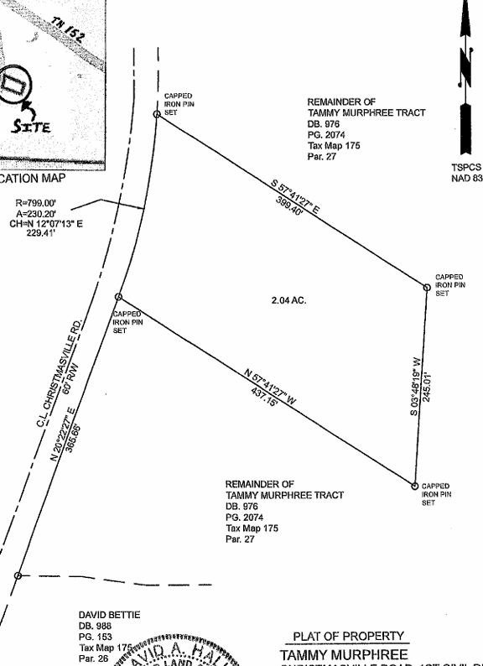

Background. A minor subdivision plat has been submitted which proposes to subdivide one lot from a parent tract (of approximately 37.36 acres). The proposed lot would be 2.04 acres in size. The property is owned by Tammy Murphree. The subject property is located in Medina’s Planning Region (subject to the Gibson County Zoning Resolution) on Christmasville Road and it is zoned A-1 (Agricultural, Forestry). The property is vacant and will be served by a proposed septic system and a proposed well. The property does not appear to be located in a designated flood hazard area.

Analysis. The staff planner has the following concerns:

- None of the required certificates, necessary for final plat approval, are included on the submittal.

- The proposed septic field area should be shown on the plat.

- The present zoning of the subject property is supposed to be stated on the plat.

Recommendation. The staff planner recommends the above noted concerns be addressed prior to approval.

V. OLD BUSINESS
VI. OTHER BUSINESS
VII. ADJOURNMENT

