**AGENDA FOR THE**

**MEDINA MUNICIPAL/REGIONAL**

**PLANNING COMMISSION MEETING**

**MONDAY, JUNE 2, 2025**

**5:00 PM**

**I. DETERMINATION OF QUORUM AND CALL TO ORDER**

**II. REVIEW AND APPROVAL OF MINUTES**

**III. CITIZENS COMMENTS**

**IV. NEW BUSINESS**

1. **Performance Bond Release / Maintenance Bond Establishment – Graves Crossing North – Phase 2, Sections 1 & 2**
2. **Rezoning Request – Clay Goodrich**

**V. OLD BUSINESS**

1. **Discussion on potential expansion of Urban Growth Boundary**

**V. OLD BUSINESS**

**VI. OTHER BUSINESS**

* **VII. ADJOURNMENT**



MEMORANDUM

TO: Medina Municipal / Regional Planning Commission

FROM: Donny Bunton, Community Planner

DATE: May 27, 2025

SUBJECT: STAFF PLANNER’S REPORT ON AGENDA ITEMS

**I. DETERMINATION OF QUORUM AND CALL TO ORDER**

**II. REVIEW AND APPROVAL OF MINUTES**

**III. CITIZENS COMMENTS**

**IV. NEW BUSINESS**

1. **Performance Bond Release / Maintenance Bond Establishment – Graves Crossing North – Phase 2, Sections 1 & 2**

Clark Family Homes is requesting the release of the following performance bonds:

Graves Crossing North – Phase 2, Section 1 ($73,065 dated 1/16/24)

Graves Crossing North – Phase 2, Section 2 ($124,480 dated 5/13/24)

Maintenance bonds would need to be established for both sections. The staff planner defers recommendation on this matter to the City Engineer.

1. **Rezoning Request – Clay Goodrich**

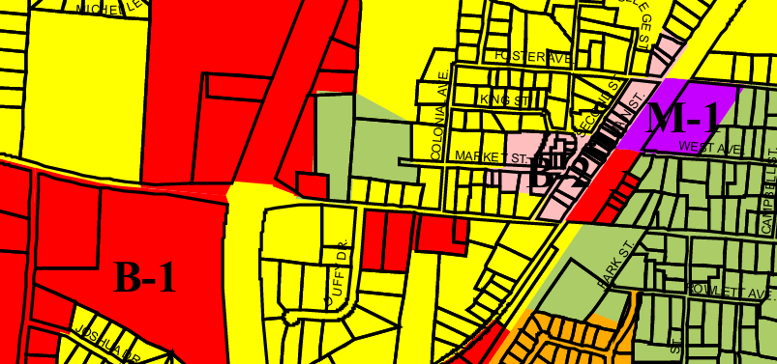

**R-2**

###### **Background.** Mr. Goodrich (on behalf of MGM Properties) has requested the rezoning of property located at 357 West Church Street from B-1 (General Business) to R-2 (High Density Residential). MGM Properties owns an existing multi-family use on an abutting property (Cherrywood Apartments at 545 West Church Street), which it would it like to expand onto the subject property. The subject property is approximately 30,600 square feet in size, while the adjacent property (which contains multi-family use) is approximately 3.33 acres in size. The property does not appear to be located in a designated flood hazard area. The property was previously zoned R-2, but it was rezoned to B-1 in 2009.

**Analysis.** The staff planner has the following comments:

* The property was previously zoned R-2, but it was rezoned to B-1 in 2009. The property is designated for commercial growth by the City’s adopted future land use map, meaning a rezoning (back to R-2) would contradict said designation for commercial growth.
* The property abuts an existing R-2 zoning district, so the proposed rezoning would not constitute an apparent spot zone.

**Recommendation.** The staff planner recommends the property remain zoned B-1.

**V. OLD BUSINESS**

1. **Discussion on potential expansion of Urban Growth Boundary**

The Planning Commission will continue discussion on potentially expanding the City’s Urban Growth Boundary (UGB). The City’s existing UGB was approved as part of the original County Growth Plan, which was ratified by the State on January 26, 2000.

Two months ago, the Planning Commission recommended an option for expansion which basically comprises the remaining rural area west of the City, located between Medina and Humboldt’s existing Urban Growth Boundaries (see below).

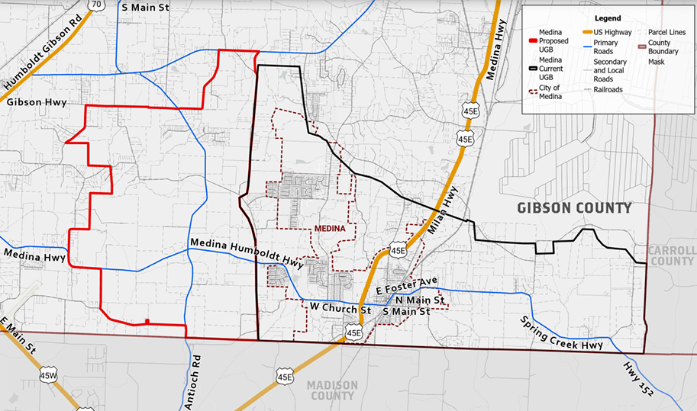

In order to amend the UGB an updated Urban Growth Boundary report must first be adopted by the City and then adopted as part of the County’s growth plan by the County Coordinating Committee, the County Commission, and each of the municipalities within the County. A series of public hearings must also be held in conjunction with the above approvals. After all of the above approvals are completed, the updated County Growth Plan must then be ratified by the Local Government Planning Advisory Committee (LGPAC) which operates as part of the Tennessee Department of Economic and Community Development.

The staff planner has mostly completed a draft of the proposed revised Urban Growth Boundary Report, which will be discussed by the Planning Commission. We are still awaiting an estimate for potential utility expansion costs for the proposed UGB. When that information is received, the process can proceed.

**V. OLD BUSINESS**

**VI. OTHER BUSINESS**

**VII. ADJOURNMENT**