**AGENDA FOR THE**

**MEDINA MUNICIPAL/REGIONAL**

**PLANNING COMMISSION MEETING**

**MONDAY, MAY 13, 2024**

**5:00 PM**

**I. DETERMINATION OF QUORUM AND CALL TO ORDER**

**II. REVIEW AND APPROVAL OF MINUTES**

**III. CITIZENS COMMENTS**

**IV. NEW BUSINESS**

1. **Final Plat – Graves Crossing North, Phase 2, Section 2**
2. **Construction Drawings – Graves Crossing North, Phases 3 & 4**
3. **Discussion on potentially revising R-2 provisions**
4. **Discussion on proposed “Medina Land Use & Development Plan”**

**V. OLD BUSINESS**

**VI. OTHER BUSINESS**

1. **Discussion on potentially changing meeting date & time**

**VII. ADJOURNMENT**



MEMORANDUM

TO: Medina Municipal / Regional Planning Commission

FROM: Donny Bunton, Community Planner

DATE: May 7, 2024

SUBJECT: STAFF PLANNER’S REPORT ON AGENDA ITEMS

**I. DETERMINATION OF QUORUM AND CALL TO ORDER**

**II. REVIEW AND APPROVAL OF MINUTES**

**III. CITIZENS COMMENTS**

**IV. NEW BUSINESS**

1. **Final Plat – Graves Crossing North, Phase 2, Section 2**

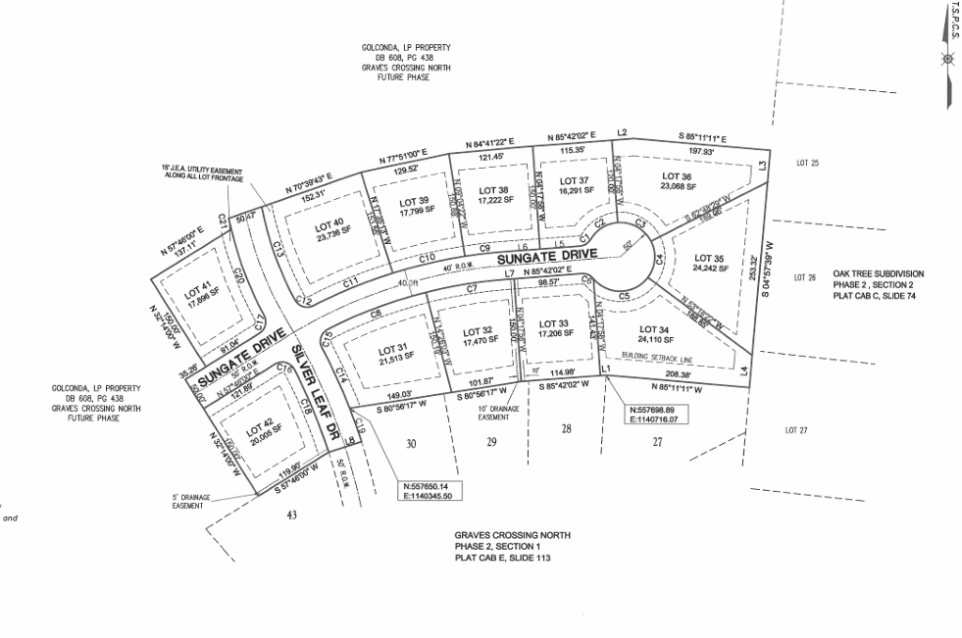

**Background.** A final plat has been submitted for Graves Crossing North Subdivision, Phase 2, Section 2. The proposal would create twelve lots and portions of two proposed streets (Sungate Drive & Silver Leaf Drive). The size of the proposed development is 6.69 acres and the property is zoned R-1A. Water and sewer extensions are also proposed to parallel the proposed street extensions. The property does not appear to be located in a designated flood hazard area.

**Analysis.** The staff planner finds no deficiencies with the submitted plat, as it appears to meet all minimum criteria.

**Recommendation.** The staff planner recommends approval, so long as an appropriate performance bond is posted, as specified by the City Engineer.

1. **Construction Drawings – Graves Crossing North, Phases 3 & 4**

**Background.** Construction drawings have been submitted for Graves Crossing North Subdivision, Phases 3 & 4. The two phases propose to create 31 lots on 14.775 acres of property. The proposal includes a common area space totaling 29,610.49 square feet in size. The property is zoned R-1A and it is not located in a designated flood hazard area. Portions and entireties of three streets are proposed as part of these phases, in addition to the accompanying water and sewer lines.

**Analysis.** The staff planner has the following concerns:

* The design and location of utility poles (to contain lighting) have not been shown, as required.
* A debris removal plan has not been included.

**Recommendation.**  The staff planner defers recommendation on the construction drawings to the City Engineer.

1. **Discussion on potentially revising R-2 provisions**

Shane McAlexander, with Highway 152 Partners, has requested that the R-2 district provisions be revised so that:

* The minimum lot size is reduced from 9,000 square feet to 7,800 square feet.
* The minimum lot width is reduced from 70 feet to 60 feet.

These requests are being made so that some flexibility may be utilized in developing their recently annexed property located at the southeast corner of Highway 152 and Mayes Lane (see below). The property is zoned R-2. A proposal, in 2023, to create a new residential district, which would have benefitted the subject development, failed to gain the approval of the City Board.

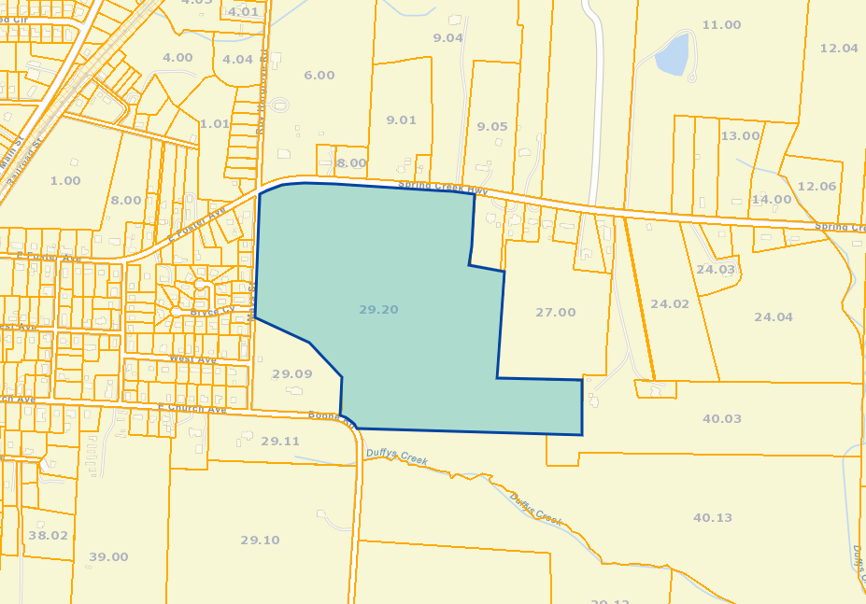

1. **Discussion on proposed “Medin Land Use & Development Plan”**

The staff planner will present the narrative portion of a proposed land use and development plan for the City. The plan will be comprised of updated growth policies, an updated future land use map, and an updated major road plan. The document is intended to guide growth decisions in Medina over a twenty year period.

**V. OLD BUSINESS**

**VI. OTHER BUSINESS**

1. **Discussion on potentially changing meeting date & time**

The Planning Commission will discuss potentially changing the date and time of the monthly Planning Commission meeting from the 2nd Monday @ 5:30 pm to the 1st Monday @ 5:00 pm.

**VII. ADJOURNMENT**