**AGENDA FOR THE**

**MEDINA MUNICIPAL/REGIONAL**

**PLANNING COMMISSION MEETING**

**MONDAY, SEPTEMBER 8, 2025**

**5:00 PM**

**I. DETERMINATION OF QUORUM AND CALL TO ORDER**

**II. REVIEW AND APPROVAL OF MINUTES**

**III. CITIZENS COMMENTS**

**IV. NEW BUSINESS**

1. **Maintenance Bond Release - Graves Crossing North, Phase 1**
2. **Maintenance Bond Release – Arbor Oaks Subdivision, Phase 3, Section 2**

**V. OLD BUSINESS**

1. **Revised Final Plat – Bank of Milan Subdivision – Lots 1 & 1A**

**VI. OTHER BUSINESS**

**VII. ADJOURNMENT**



MEMORANDUM

TO: Medina Municipal / Regional Planning Commission

FROM: Donny Bunton, Community Planner

DATE: September 2, 2025

SUBJECT: STAFF PLANNER’S REPORT ON AGENDA ITEMS

**I. DETERMINATION OF QUORUM AND CALL TO ORDER**

**II. REVIEW AND APPROVAL OF MINUTES**

**III. CITIZENS COMMENTS**

**IV. NEW BUSINESS**

1. **Maintenance Bond Release – Graves Crossing North – Phase 1**

Kevin Clark, on behalf of KOKA Development, is requesting the release of the maintenance bond for Phase 1 of Graves Crossing North Subdivision. It appears that the bond is in the amount of $34,320. The bond was established on 8/5/2024. The staff planner defers recommendation on this matter to the City Engineer.

1. **Maintenance Bond Release – Arbor Oaks Subdivision, Phase 3, Section 2**

Kevin Clark, on behalf of KOKA Development, is requesting the release of the maintenance bond for Phase 3, Section 2 of Arbor Oaks Subdivision. It appears that the bond is in the amount of $43,500. The bond was established on 8/5/2024. The staff planner defers recommendation on this matter to the City Engineer.

**V. OLD BUSINESS**

1. **Revised Final Plat – Bank of Milan Subdivision – Lots 1 & 1A**

###### **Background.** A final plat has been submitted which would split an existing property into two proposed lots. The property (Tax Map 176, Parcel 1.03) is 3.2 acres in size and it is zoned B-1 (General Business). Per the submitted plat, the property has access to sewer service. A water line is not shown, but given the property’s location (and the fact that a fire hydrant is present) it is assumed that the property has access to water service. The property is owned by the Bank of Milan. The size of the proposed lots are:

Lot 1 (which contains the existing Bank of Milan): 2.11 acres

Lot 1A (vacant): 1.06 acres.

The property was originally created, via a subdivision plat, approved on June 9, 1997. The original plat shows the lots receiving street access from Rhodes Drive, which is labeled simply as “Dedicated Road Right-Of-Way.” There is no indication that any street improvements were proposed and that right-of-way was dedicated, as part of the original process.

This proposal was originally submitted for discussion during the July Planning Commission meeting. However, the plat was withdrawn during that meeting until such time when some of the underlying issues could be resolved. Specifically, it needed to be determined if Rhodes Drive had been improved up to city street standards and, if not, who would be responsible for making needed improvements. According to expert analysis of a recently completed core test, the street base is adequate but 2.5 inches of asphalt wearing surface should be added to the street.

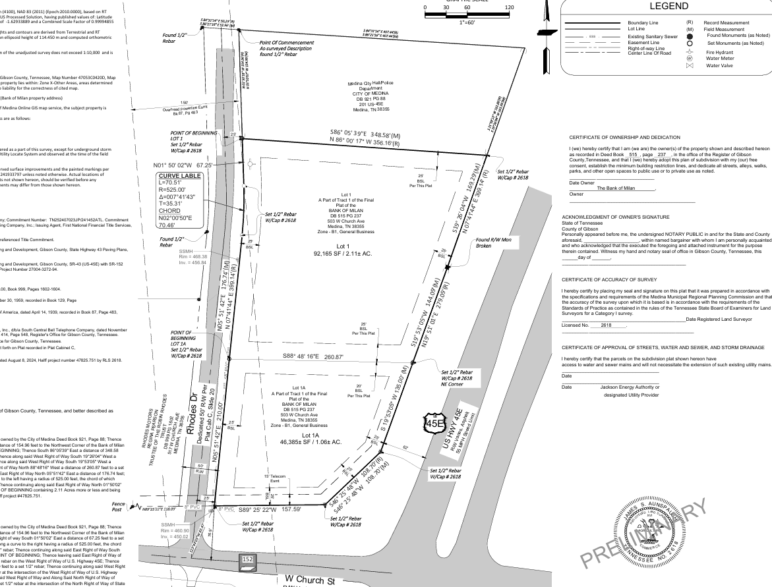

**Analysis.** The staff planner has the following comments:

* Per informal discussions between the City and the Bank of Milan (since the July meeting), it has been determined that:
* It will be acceptable for the Bank of Milan to proceed with its previously submitted minor subdivision plat.  The proposal will be considered a minor subdivision plat, as street improvements and construction drawings will not be required as part of the subdivision process.
* After approval of the minor subdivision plat, a site plan can then be submitted for development of the subdivided lot.  If the subdivided lot is proposed for development as a convenience store (as previously discussed), then 2.5 inches of additional asphalt wearing surface improvements will be required (along the lot’s Rhodes Drive frontage) to accommodate heavier loads of traffic customary to convenience stores.  This required improvement is based on the analysis of a core test sample for Rhodes Drive by Construction Materials Laboratory Incorporated and their subsequent recommendation.

* A 15’ JEA easement is needed along all street frontages.
* The location and size of the nearest existing water main should be shown.
* Normally, a cul-de-sac (either permanent or temporary) is required at the terminus of a dead-end street. In this case, the Planning Commission may feel that a cul-de-sac is not needed at the northern end of Rhodes Drive, since there is ample room for vehicles to turn around in the adjacent parking lot for the Fire Department.
* The “Certificate of Approval of Streets, Water and Sewer and Storm Drainage,” provided on the plat should be replaced by the following certificate to be signed by JEA: “Certificate of Recognition of Existing Water and Sewer Mains.”
* A “Certificate of Recognition of Existing Streets, Storm Drainage and Rights-of-Way” to be signed by the City Engineer should be added.
* The required “Certificate of Approval” by the Planning Commission has been left off of the submitted plat.

**Recommendation.** The staff planner recommends the above noted comments be addressed prior to approval.

**VI. OTHER BUSINESS**

**VII. ADJOURNMENT**